**TUGAS 5**

**TUGAS MANDIRI**

**Nama : Wahyudin Zaelani**

**Nim : 1127050167**

**1. Buat state diagram dan activity diagram untuk class diagram vending machine !**

State Diagram “Vending Machine”

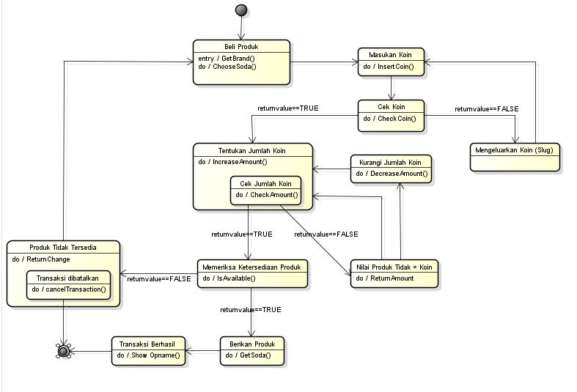

State Diagram “Coin Handler” 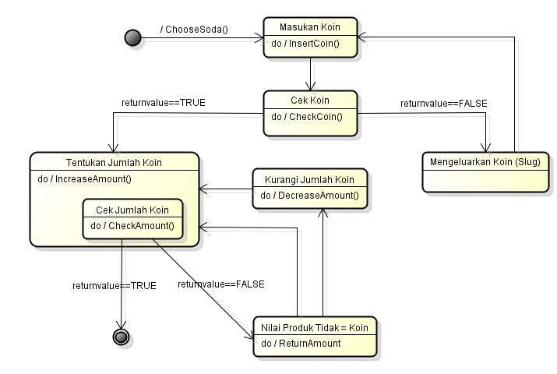State Diagram “Stok”  
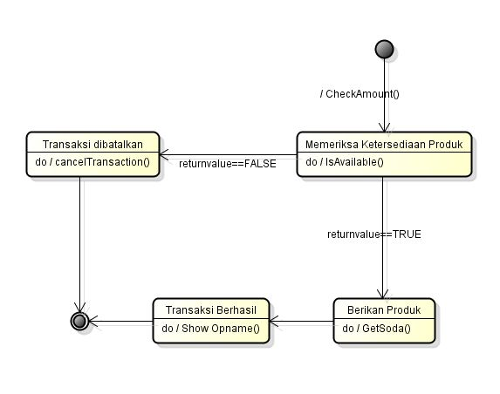

Activity Diagram “Vending Machine”

